Contents

Packages to install: 1

Pre-requisites: 1

Activities: 1

Create Action catalogue: 4

Task Action 8

# Packages to install:

1. UiPath.FormActivityLibrary
2. UiPath.Persistence.Activities

# Pre-requisites:

1. Enable action center in cloud.uipath.com->Admin->Tenants->Tenant Settings->Enable Actions
2. Project Settings->Enable support persistence
3. Install the above packages

# Activities:

1. **Input dialogue –** just for taking input for testing purpose

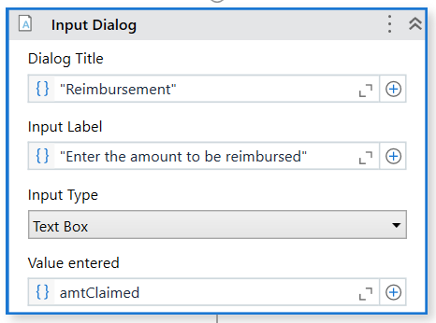

1. **Create Form Task**

* Task title- give the title that should be visible in the task
* Task priority- choose the priority
* Task catalog- we need to give the action catalog name that we created in orchestrator (explained in the below steps)
* Form data- In the collection, pass the input and output arguments
* Open Form Designer- this will create a form based on the collection you have given
* Task object- is the output

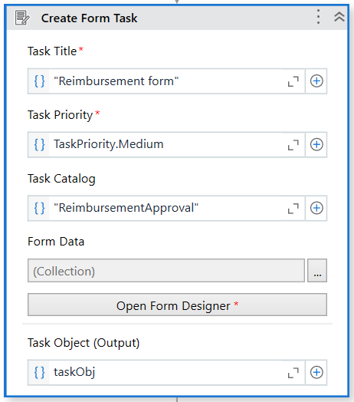

1. **Wait for Form Task & Resume**

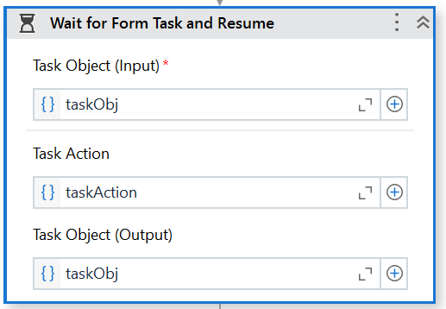

Here we are using input dialog to take the value and supply to the next activities. Create form task activity will create a task in the Action Center and the execution is paused until the next activity “Wait for forum task”.

Now it is our duty to approve in the action center and then resume the execution here in the Uipath studio. This is the case with attended mode.

Like below, task will be under “unassigned”, we need to “Assign to self” and then the task moves to “pending” field where we can approve

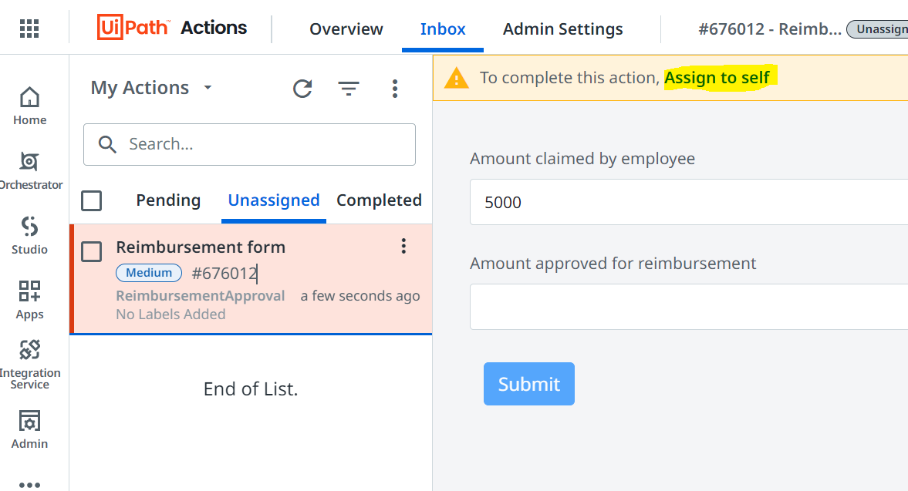

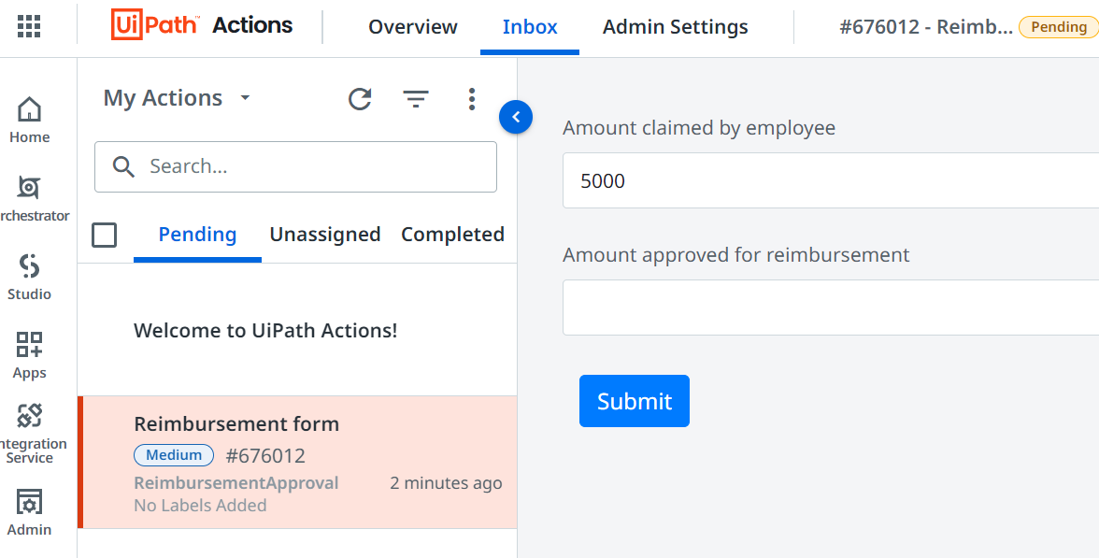

Once we publish the package to orchestrator and run-in unattended mode then automatically the execution will be resumed from the activity “Wait for forum task” once we approve the task in Action Centre. Below is the output of attended execution.

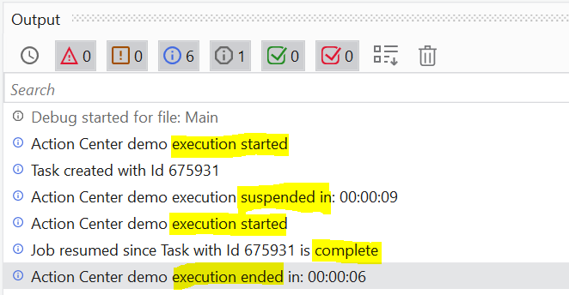

Once approved, task falls under the field “Completed” like below

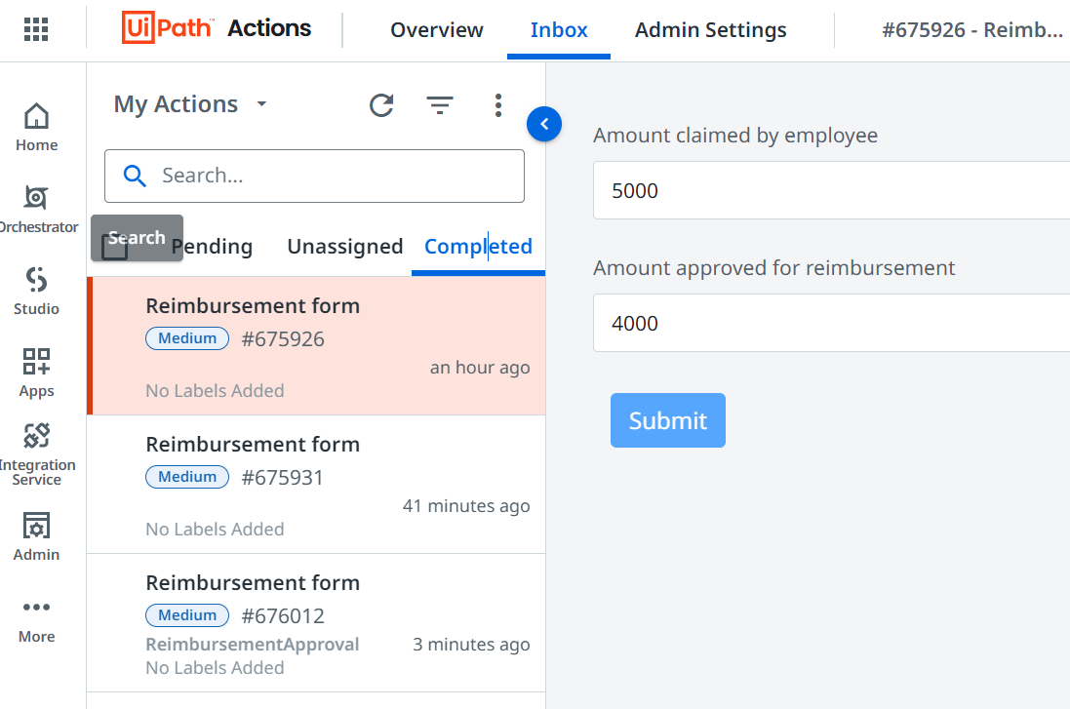

1. **Switch**

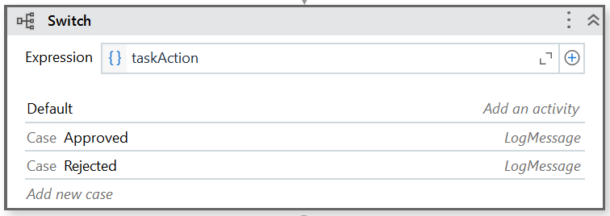

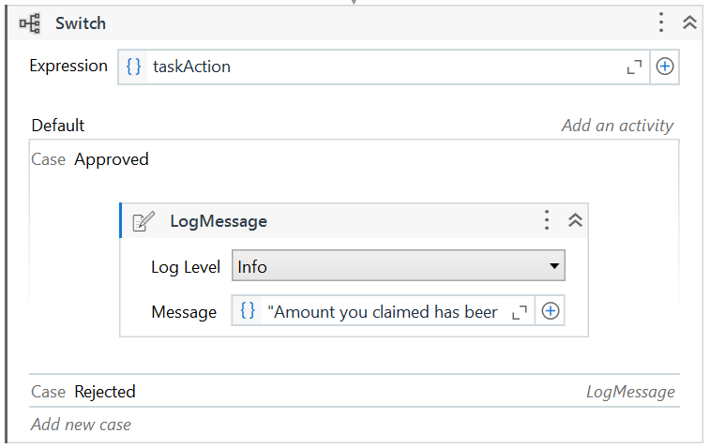

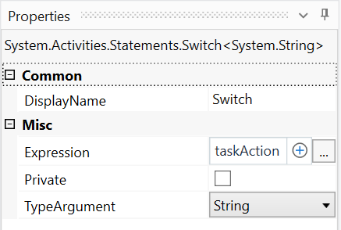

1. **Assign Tasks:**

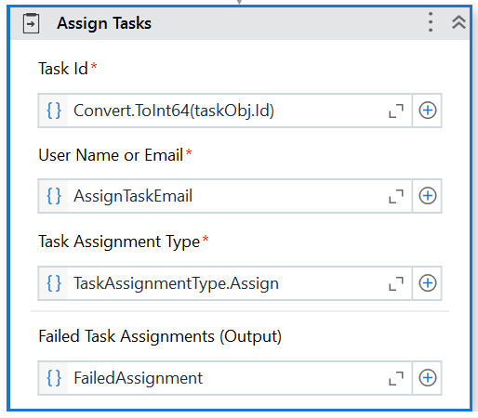

# Create Action catalogue:

Action Catalog enables automations to group actions as per business categories, thus helping the users to filter, search and prioritize actions.

Admin Settings->Folder (which studio is linked with)->Add New Catalogue->Give title & description->Save->It will reflect as shown in the below snap

When the task gets created it will be categorized as per the title you provide in the catalogue. Whatever name you have provided, we are going to create a category of task under this catalogue title name

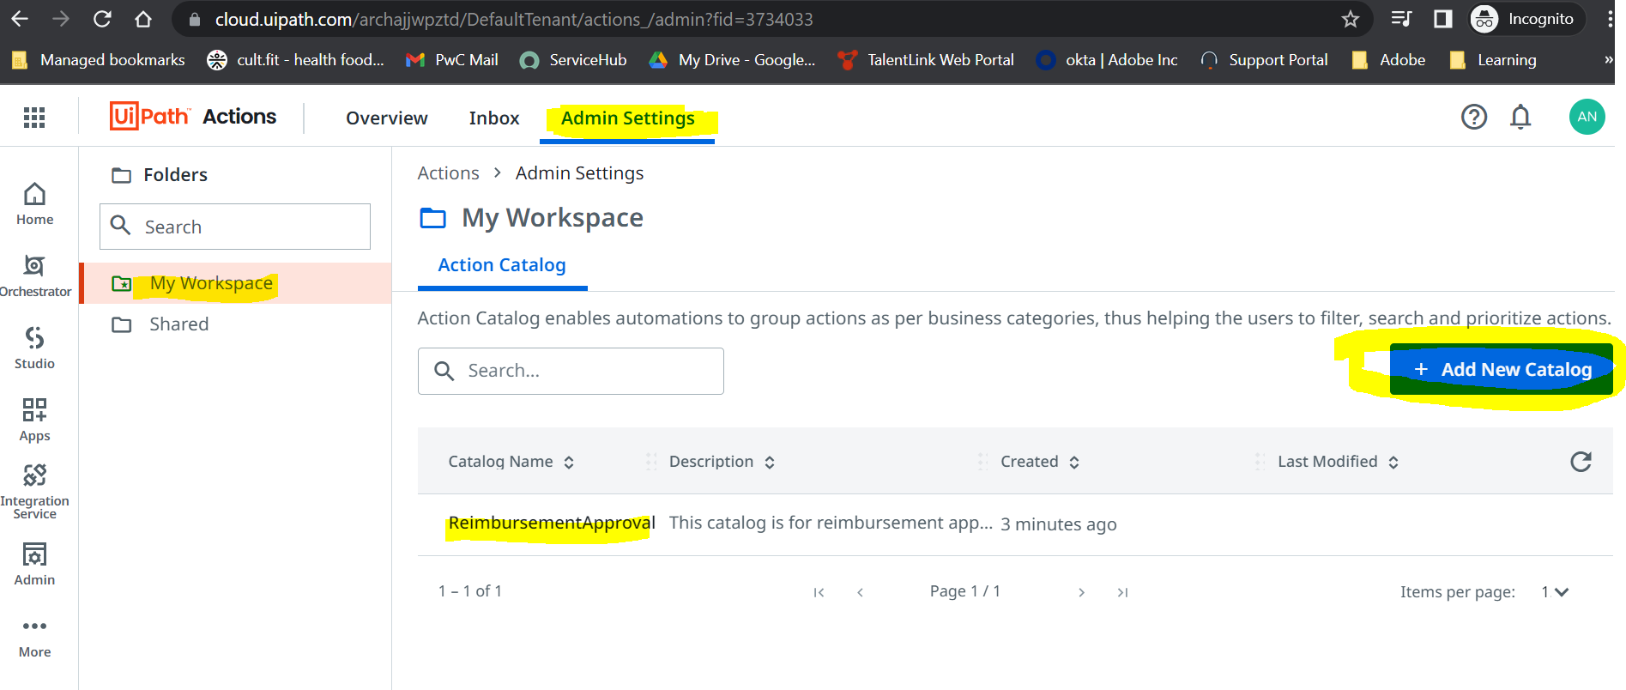

In the above activity “Create Form Task” we have left the field “Task Catalogue” empty & the output after the task is completed looks like below which will not have any category mapped to it because of not specifying any catalogue in the activity.

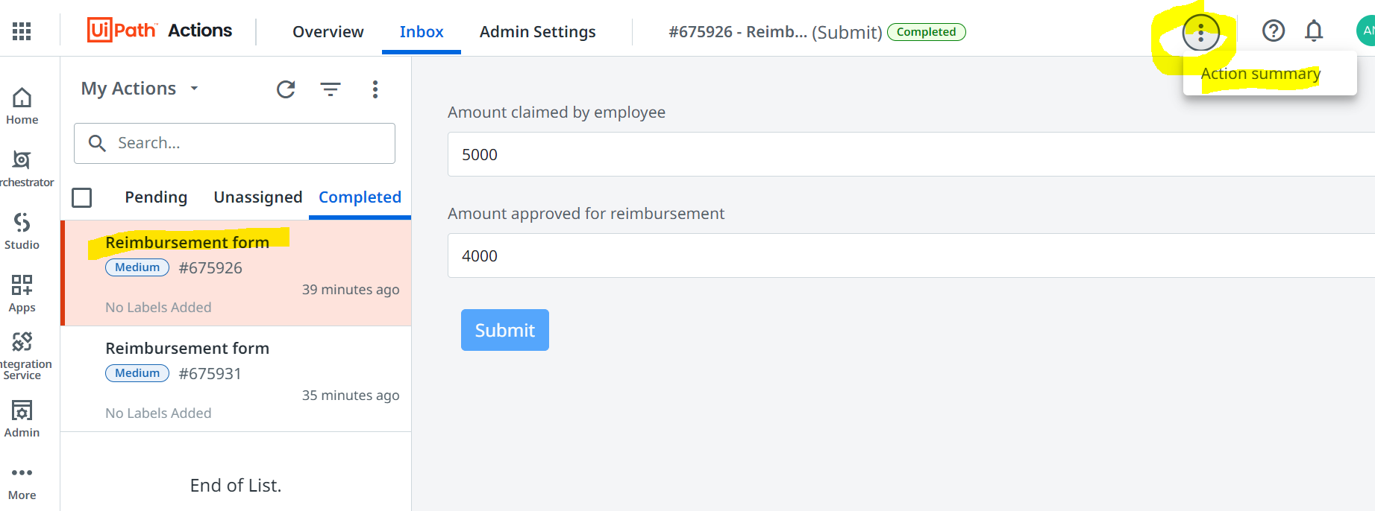

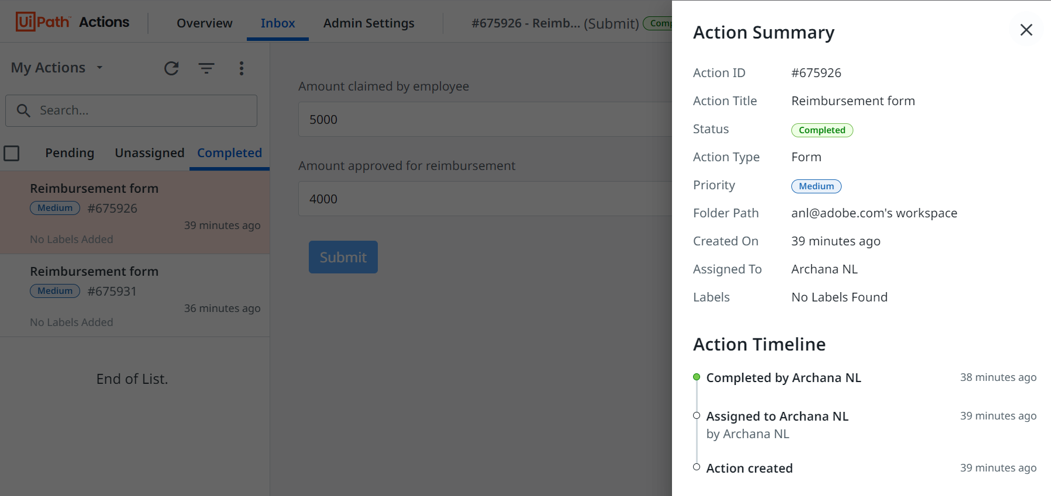

Use the catalogue title you created under the folder (linked with studio) in the activity “Create Form Task” in the field “Task catalogue” like below

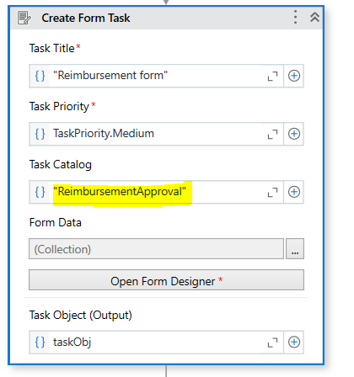

After the execution is complete & task is approved, go to Action Summary of that task, looks like below

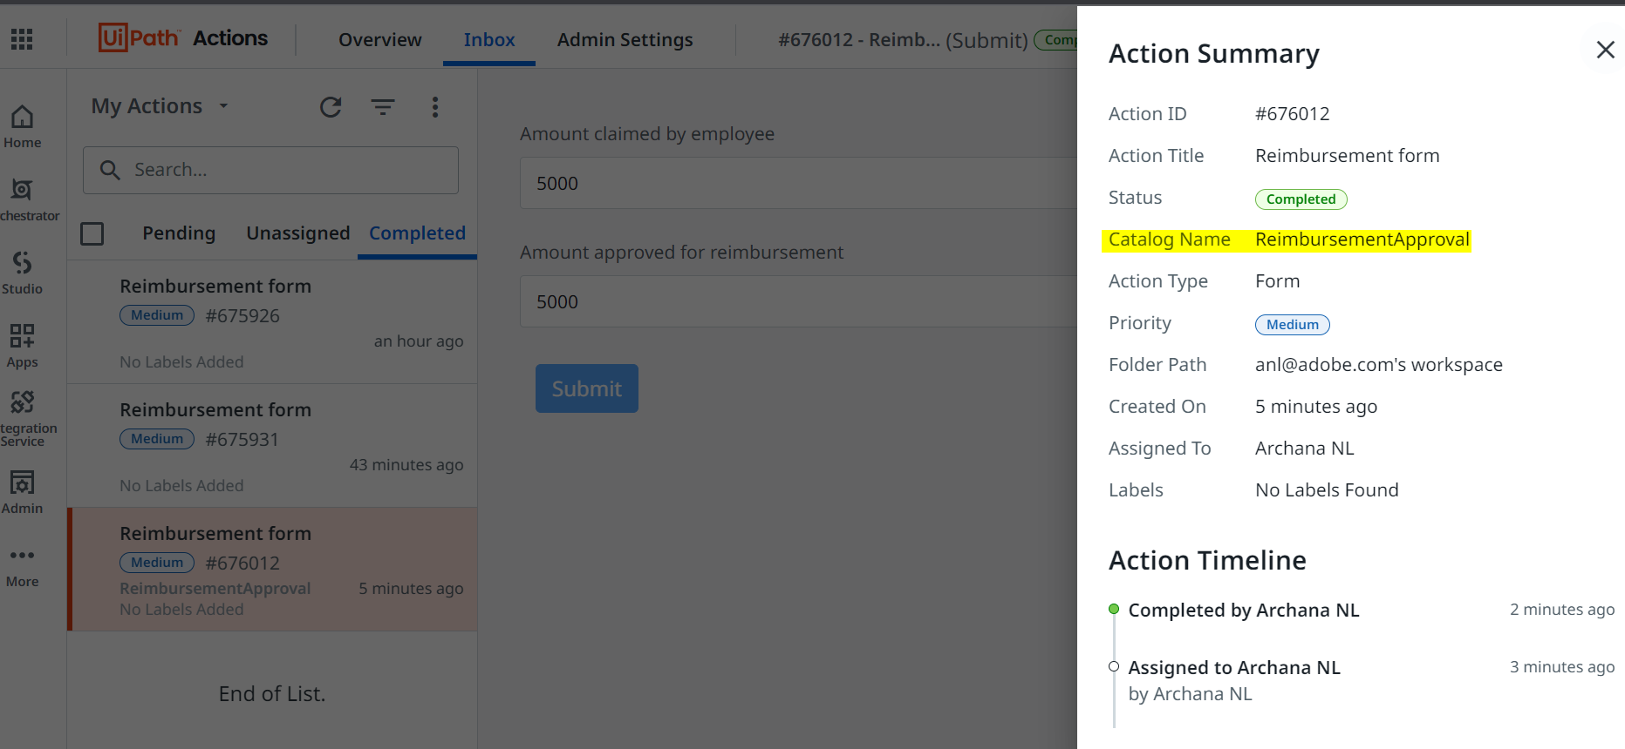

Also, we can filter the tasks using the catalogue names and then approve the tasks when the flow is huge.

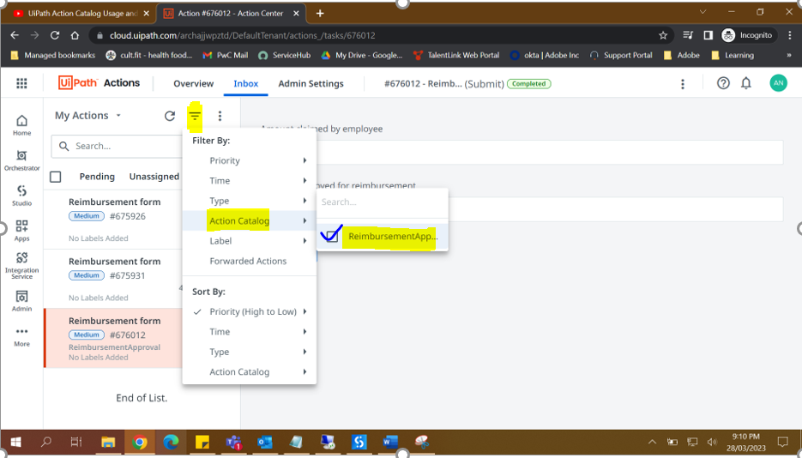

**NOTE**: If we use the “Action catalogue” which is not defined in the orchestrator, then the task will not have any category in it & doesn’t belong to any category, so we need to define the correct Action catalogue created in the orchestrator.

# Task Action

This will get created once we perform the approve/reject task in orchestrator. Whatever task you perform becomes Task action & based on Task action, further decisions will be taken. Example: Switch activity used above.

# Assign tasks automatically